Experimental Design and Graphical Analysis of Data

A. Designing a controlled experiment

When scientists set up experiments they often attempt to determine how a given variable affects another variable. This requires the experiment to be designed in such a way that when the experimenter changes one variable, the effects of this change on a second variable can be measured. If any other variable that could affect the second variable is changed, the experimenter would have no way of knowing which variable was responsible for the results. For this reason, scientists always attempt to conduct controlled experiments. This is done by choosing only one variable to manipulate in an experiment, observing its effect on a second variable, and holding all other variables in the experiment constant.

Suppose you wanted to test how changing the mass of a pendulum affects the time it takes a pendulum to swing back and forth (also known as its period). You must keep all other variables constant. You must make sure the length of the pendulum string does not change. You must make sure that the distance that the pendulum is pulled back (also known as the amplitude) does not change. The length of the pendulum and the amplitude are variables that must be held constant in order to run a controlled experiment. The only thing that you would deliberately change would be the mass of the pendulum. This would then be considered the independent variable, because you will decide how much mass to put on the pendulum for each experimental trial. There are three possible outcomes to this experiment: 1. If the mass is increased, the period will increase. 2. If the mass is increased, the period will decrease. 3. If the mass is increased, the period will remain unchanged. Since you are testing the effect of changing the mass on the period, and since the period may depend on the value of the mass, the period is called the dependent variable.

In review, there are only two variables that area allowed to change in a well-designed experiment. The variable manipulated by the experimenter (mass in this example) is called the independent variable. The dependent variable (period in this case) is the one that responds to or depends on the variable that was manipulated. Any other variable which might affect the value of the dependent value must be held constant. We might call these variables controlled variables. When an experiment is conducted with one (and only one) independent variable and one (and only one) dependent variable while holding all other variables constant, it is a controlled experiment.

B. Characteristics of Good Data Recording

- Raw data is recorded in ink. Data that you think is "bad" is not destroyed. It is noted but kept in case it is needed for future use.
- The table for raw data is constructed prior to beginning data collection.
- The table is laid out neatly using a straightedge.
- The independent variable is recorded in the leftmost column (by convention).
- The data table is given a descriptive title which makes it clear which experiment it represents.
- Each column of the data table is labeled with the name of the variable it contains.
- Below (or to the side of) each variable name is the name of the unit of measurement (or its symbol) in parentheses.
- Data is recorded to an appropriate number of decimal places as determined by the precision of the measuring device or the measuring technique.
- All columns in the table which are the result of a calculation are clearly explained and sample calculations are shown making it clear how each column in the table was determined.
- The values held constant in the experiment are described and their values are recorded.

C. Graphing Data
Once the data is collected, it is necessary to determine the relationship between the two variables in the experiment. You will construct a graph (or sometimes a series of graphs) from your data in order to determine the relationship between the independent and dependent variables.

For each relationship that is being investigated in your experiment, you should prepare the appropriate graph. In general your graphs in physics are of a type known as scatter graphs. The graphs will be used to give you a conceptual understanding of the relation between the variables, and will usually also be used to help you formulate mathematical statement which describes that relationship. Graphs should include each of the elements described below:
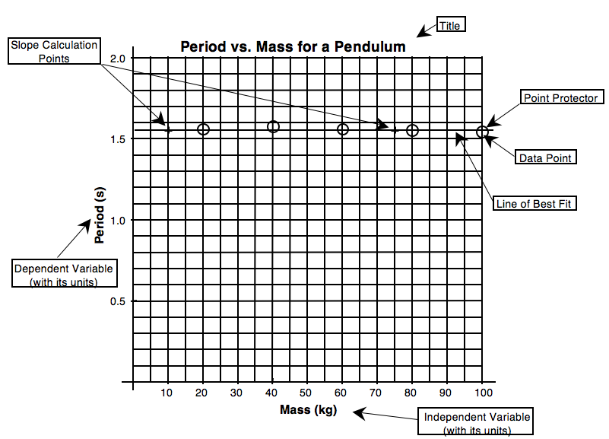Elements of Good Graphs
- A title that describes the experiment. This title should be descriptive of the experiment and should indicate the relationship between the variables. It is conventional to title graphs with DEPENDENT VARIABLE vs. INDEPENDENT VARIABLE. For example, if the experiment was designed to show how changing the mass of a pendulum affects its period, the mass of the pendulum is the independent variable and the period is the dependent variable. A good title might therefore be PERIOD vs. MASS FOR A PENDULUM.
- The graph should fill the space allotted for the graph. If you have reserved a whole sheet of graph paper for the graph then it should be as large as the paper and proper scaling techniques permit.
- The graph must be properly scaled. The scale for each axis of the graph should always begin at zero. The scale chosen on the axis must be uniform and linear. This means that each square on a given axis must represent the same amount. Obviously each axis for a graph will be scaled independently from the other since they are representing different variables. A given axis must, however, be scaled consistently.
- Each axis should be labeled with the quantity being measured and the units of measurement. Generally, the independent variable is plotted on the horizontal (or x) axis and the dependent variable is plotted on the vertical (or y) axis.
- Each data point should be plotted in the proper position. You should plot a point as a small dot at the position of the of the data point and you should circle the data point so that it will not be obscured by your line of best fit. These circles are called point protectors.
- A line of best fit. This line should show the overall tendency (or trend) of your data. If the trend is linear, you should draw a straight line which shows that trend using a straight edge. If the trend is a curve, you should sketch a curve which is your best guess as to the tendency of the data. This line (whether straight or curved) does not have to go through all of the data points and it may, in some cases, not go through any of them.
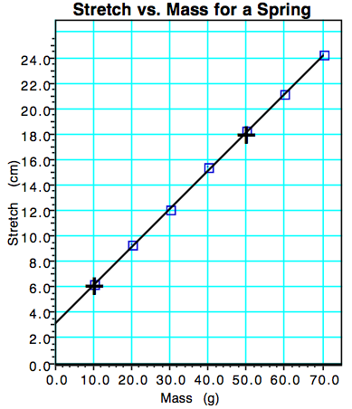
- Do not, under any circumstances, connect successive data points with a series of straight lines, dot to dot. This makes it difficult to see the overall trend of the data that you are trying to represent.
- If you are plotting the graph by hand, you will choose two points for all linear graphs from which to calculate the slope of the line of best fit. These points should not be data points unless a data point happens to fall perfectly on the line of best fit. Pick two points which are directly on your line of best fit and which are easy to read from the graph. Mark the points you have chosen with a +.
- Do not do other work in the space of your graph such as the slope calculation or other parts of the mathematical analysis.
- If your graph does not yield a straight line, you will be expected to manipulate one (or more) of the axes of your graph, replot the manipulated data, and continue doing this until a straight line results. We will address the details of linearization later in the course.

D. Graphical Analysis and Linear Mathematical Models

When the data you collect yields a linear graph, you will proceed to determine the mathematical equation that describes the relationship between the variables using the slope intercept form of the equation of a line. Consider the following experiment in which the experimenter tests the effect of adding various masses to a spring on the amount that the spring stretches. The development of the mathematical model is shown on the next page.

Begin with the equation for a line: y = mx + b
Determine the slope and y-intercept from graph slope (m) = 0.30 (cm/g); y-intercept = 3.2 cm
Substitute constants with units from experiment y = [0.30 (cm/g)]x + 3.2 cm
Substitute variables from experiment
Stretch = S; mass = m S = [0.30 (cm/g)]m + 3.2 cm
Final mathematical model: S = [0.30 (cm/g)]m + 3.2 cm

The result of this experiment, then, is a mathematical equation which models the behavior of the spring:
Stretch = 0.30 cm/g · mass + 3.2 cm
With this mathematical model we know many characteristics of the spring and can predict its behavior without actually further testing the spring. In models of this type, there is physical significance associated with each value in the equation. For instance, the slope of this graph, 0.30 cm/g, tells us that the spring will stretch 0.30 centimeters for each gram of mass that is added to it. We might call this slope the "wimpiness" of the spring, since if the slope is high it means that the spring stretches a lot when a relatively small mass is placed on it and a low value for the slope means that it takes a lot of mass to get a little stretch.
The y-intercept of 3.2 cm tells us that the spring was already stretched 3.2 cm when the experimenter started adding mass to the spring. With this mathematical model, we can determine the stretch of the spring for any value of mass by simply substituting the mass value into the equation. How far would the spring be stretched if 57.2 g of mass were added to the spring? Mathematical models are powerful tools in the study of science and we will use those that you develop experimentally as the basis of many of our studies in physics.

When you are evaluating real data, you will need to decide whether or not the graph should go through the origin. Given the limitations of the experimental process, real data will rarely yield a line that goes perfectly through the origin. In the example above, the computer calculated a y-intercept of 0.01 cm ± 0.09 cm. Since the uncertainty (±0.09 cm) in determining the y-intercept exceeds the value of the y-intercept (0.01 cm) it is obviously reasonable to call the y-intercept zero. Other cases may not be so clear cut. The first rule of order when trying to determine whether or not a direct linear relationship is indeed a direct proportion is to ask yourself what would happen to the dependent variable if the independent variable were zero. In many cases you can reason from the physical situation being investigated whether or not the graph should logically go through the origin. Sometimes, however, it might not be so obvious. In these cases we will assume that it has some physical significance and will go about trying to determine that significance.
Graphical Methods-Summary

A graph is one of the most effective representations of the relationship between two variables. The independent variable (one controlled by the experimenter) is usually placed on the x-axis. The dependent variable (one that responds to changes in the independent variable) is usually placed on the y-axis. It is important for you to be able interpret a graphical relationship and express it in a written statement and by means of an algebraic expression.

Graph shape | Written relationship | Modification required to linearize graph | Algebraic representation
 | As x increases, y remains the same. There is no relationship between the variables. | None | , or  y is constant
 | As x increases, y increases proportionally.  Y is directly proportional to x. | None
 | As x increases, y decreases.  Y is inversely proportional  to x. | Graph , or
 | Y is proportional to the square of x. | Graph y vs x2
 | The square of y is proportional to x. | Graph y2 vs x

When you state the relationship, tell how y depends on x ( e.g., as x increases, y …).

