Name

Date Pd

Chemistry – Unit 4 Worksheet 1

1. Identify the separation techniques pictured below. Which technique would be useful to separate a mixture of sand and salt? Of salt and water?

2. Explain why the technique at left would not be effective in separating a mixture of salt and sugar.

3. Draw particle representations for the following:

A mixture of iron and sulfur | A compound of iron and sulfur

4. Explain why a magnet can separate iron atoms from the mixture but not from the compound.
5. Consider the four containers below.
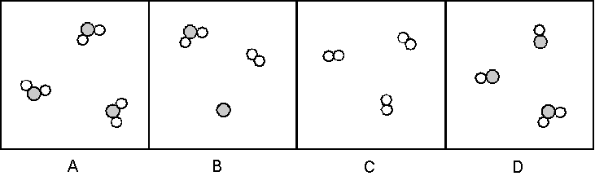
a. Which of these are mixtures? pure substances?

b. Which contain only compounds? only elements

6. Consider the four containers below.
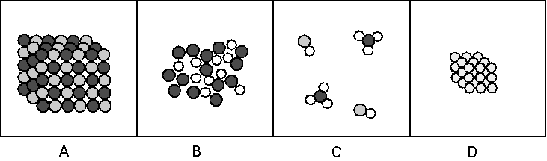
a. Which of these are mixtures? pure substances?

b. Which contain only compounds? only elements

7. Consider the four containers below.
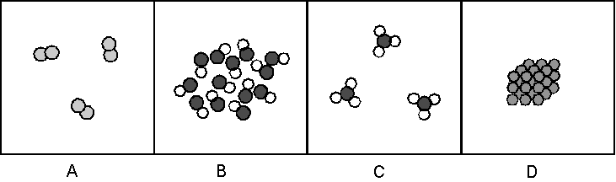
a. Which of these are mixtures? pure substances?

b. Which contain only compounds? only elements

8. Which of the containers in #7 contain a gas? a liquid a solid

