Name

Date Pd

Unit 3 - Worksheet 2

For each of the situations described below, use an energy bar chart to represent the ways that energy is stored in the system and flows into or out of the system. Below each diagram describe how the arrangement and motion of the molecules change from the initial to the final state.

1. Some of the water you spilled on your shirt evaporates.
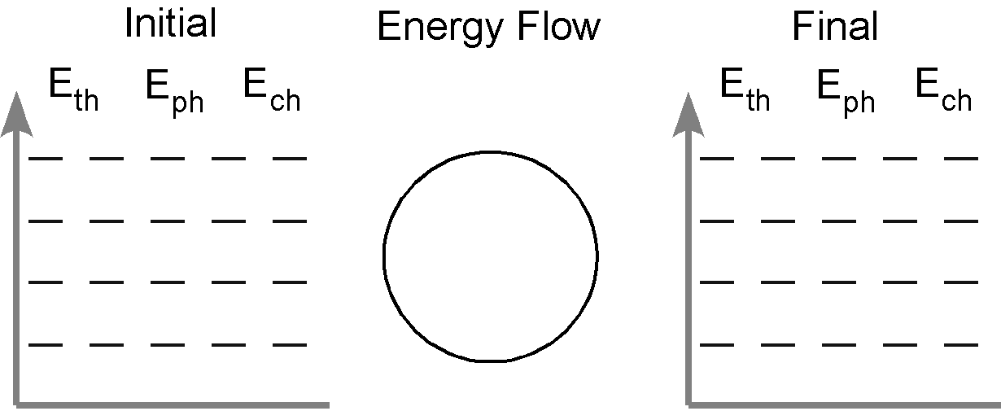

2. Water vapor in the room condenses on a cold surface

3. A pan of water (25˚C) is heated to boiling and some of the water is boiled away. Do separate energy bar charts for each stage of the process.

4. During boiling, bubbles appear in the liquid water. In the boxes below represent the arrangement of molecules inside the liquid water and inside a bubble.

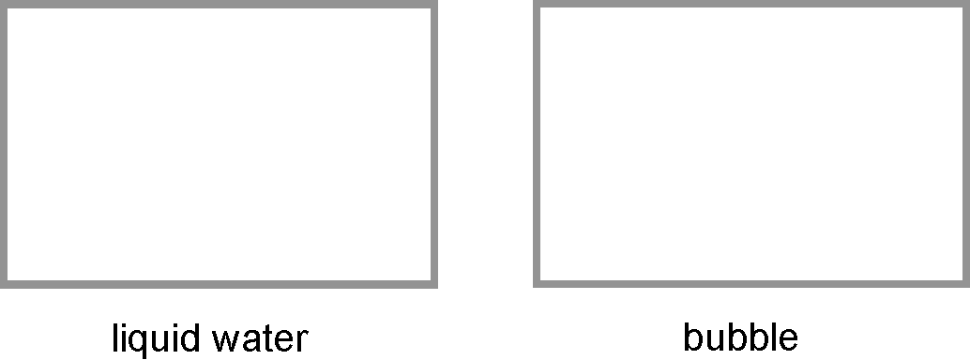

What is inside the bubble? Why do you think so?

5. Suppose the burner under the pan of boiling water is turned to a higher setting. How will this affect the temperature of the water in the pan? Explain.

6. The graph below left represents the heating curve for a liquid heated from room temperature to a temperature above its boiling point.
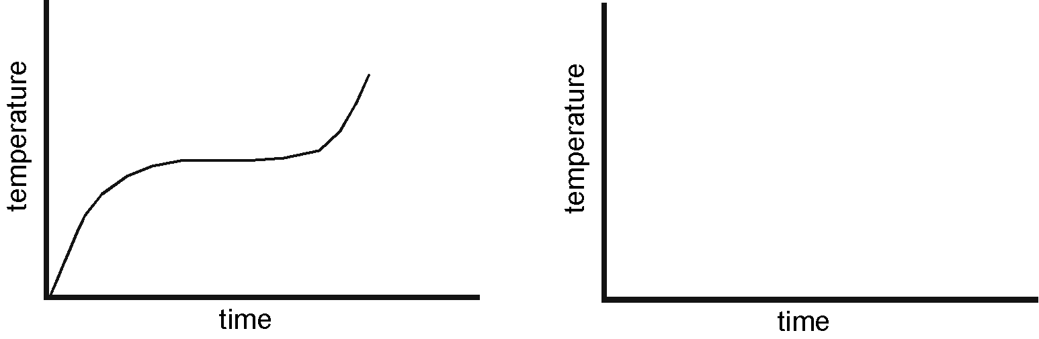
a. Sketch the heating curve for a larger sample of the same liquid.

b. Label which phase (or phases) of the substance is present in each of the three portions of the heating curve.

c. Describe the arrangement and motion of the molecules during each portion of the graph.

