Chemistry – Unit 3 Review
To prepare to do well on the Unit 3 test, you should assemble your notes, the 4 worksheets and the quiz and review them, preferably in a small group where you can draw from each other’s understanding. Here are the key points you should know.

Energy
Think of energy as a quantity that is always involved when there is a change in the state of matter. When a substance gets hotter or colder or changes phase, energy is either transferred into or out of the system. The two key ways energy is stored is thermal (due to the motion of the particles) and phase (due to attractions between the particles). Remember that attractions lower the energy state, so one must add energy to a system to pull particles apart. The three ways that energy is transferred is by heating (Q), working (W) and radiating (R); this course focuses on Q. You will be expected to be able to:

1. Draw energy bar graphs to account for energy storage and transfer in all sorts of changes. Make up a sample situation and sketch the bar graph. (review ws 1 and 2, quiz)

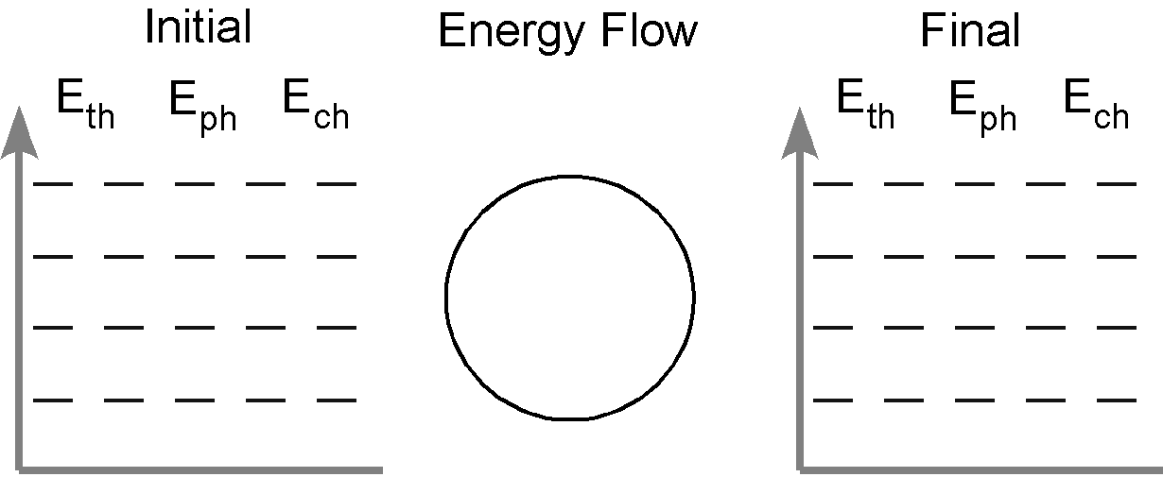

Kinetic Molecular Theory
This theory describes all matter as being composed of tiny particles in endless random motion. In a solid, the particles vibrate, but are locked into an orderly array. In a liquid, the particles are still touching but are free to move around past one another. In a gas, the particles are moving very rapidly and are widely separated.
When energy is transferred to a sample of matter, either the particles speed up (temperature increases) or they get pulled apart (phase change), but not both at the same time. This helps account for the shape of the warming curve you got in the Icy Hot lab.

2. Label which phases are present in each portion of the curve above.
3. Label the sections in which the thermal energy (Eth) of the sample is changing. Label the sections where the phase energy (Eph) is changing.

Energy calculations
First, before you do any math, you should sketch a temperature-time curve so that you can focus on what changes are taking place.

4. On the graph below left sketch the curve that describes the following:
Initial state: 150 g solid water at –10 ˚C
Final state: 150 g liquid water at 0˚C
5. On the graph above right sketch the curve that describes the following:
Initial state: 200 g liquid water at 40 ˚C
Final state: half of the water has boiled away at 100˚C

When the temperature of a solid, liquid or gas is changing, energy transfer via heating, Q, is involved. Rather than simply plug-n-chug values into an equation, reason out the quantity of Q from the value of c. For example, you know that 4.18 J is required to increase the temperature of each gram of liquid water by one Celsius degree. If you have more than one gram of water, or if the temperature changes by more than one degree, multiply by the appropriate amounts.

When the substance is undergoing a phase change (freezing or melting, condensing or evaporating), you know that you must use either Hf or Hv, both of which are factors that tell us the quantity of heat, Q involved for each gram. If more than one change is taking place, you must break the problem into steps. For these situations, temp-time graphs help you decide what is involved in each step (review ws 3).

6. Calculate the heat required to bring about the change in #4.

7. Calculate the heat required to bring about the change in #5.

8. Find your copy of The Model so Far and note changes in the model we’ve introduced in this unit.

