Name

Date Pd

Unit 2 Worksheet 2 - Measuring Pressure

Problems 1 and 2. Calculate the pressure of the gas in the flask connected to the manometer.

3. What do we mean by atmospheric pressure? What causes this pressure?

4. How do we measure atmospheric pressure? Is atmospheric pressure the same everywhere on the surface of the earth?

5. Why is the fluid in a barometer mercury, rather than water or another liquid?

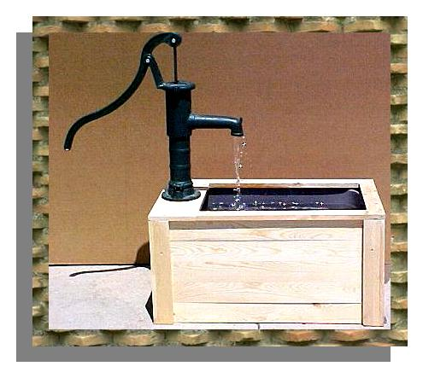
6. Explain why you cannot use a pump like the one at the right to lift water up to the 3rd floor of an apartment complex.

7. One standard atmosphere of pressure (SP) is equivalent to mmHg.

8. Convert pressure measurements from one system of units to another in the following problems.
1 atmosphere = 760 mmHg = 14.7 psi (pounds per square inch)
a. 320 mmHg x = atm
b. 30.0 psi x = mmHg
c. The barometric pressure in Breckenridge, Colorado (elevation 9600 feet) is
580 mm Hg. How many atmospheres is this?

