Chemistry - Unit 1

Scale Reading, Uncertainty and Significant Figures

Significant figures – These are all the digits you know for sure + one place that is an estimate.

Uncertainty – Limit of precision of the reading (based on your ability to estimate the final digit). See examples below.

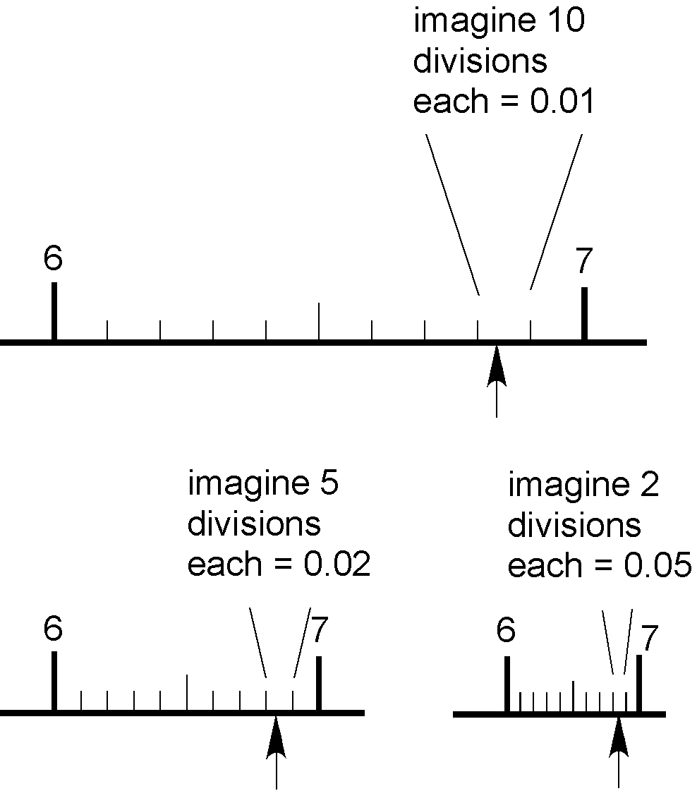

Rules for zeros: All zeros count except placeholder zeros – these are the ones that disappear when you write the number in scientific notation. Examples:

93,000,000 = 9.3 x 107 2 sf’s

0.000372 = 3.72 x 10-4 3 sf’s

0.0200 = 2.00 x 10-2 3 sf’s

